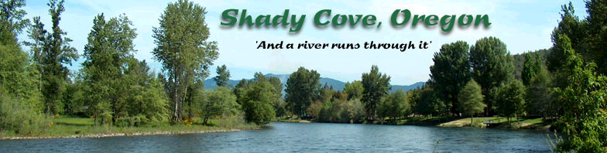

OPEN UNTIL FILLED

Application for Appointment to City Budget Committee

An extremely important committee as it reviews and assists with the annual budget for the City. While there will be multiple meetings, it’s primary focus is centered around one time of the year.

Please type or print answers to the following questions and submit to Shady Cove City Hall, or email cityadmin@shadycove.net. If you have any questions, please feel free to contact the City at 541-878-2225 or 878-3757. Attach additional sheets if necessary.

Name

Requesting to serve on:

Address (Physical)
(Mailing, if different from above)

Occupation: Phone:
Home:
Work:
Email: Fax:

1. Education Background

What schools have you attended?

What additional training or education have you had that would apply to this position?

2. Related Experience

What prior work experience have you had that would help you if you were appointed to this position?

3. Interests

Why are you applying for this position?

4. Availability

Are you available to attend meetings during the day?

5. Additional Information

How long have you lived in Shady Cove?

Please use the space below to summarize any additional qualifications you have for this position.

I authorize the City of Shady Cove to publicly review and discuss the information provided herein and to assist in responding to any questions asked which are relevant to this position.

Signature Date

