Jackson County Fire District 4

Monthly Report: September 2020

Total Number of Incidents for September 2020 72

Average Response time

 | Average Response Time | # of Calls
City limits | 5.52 | 38
Non City/Rural | 9.19 | 23

Monthly Call Volume

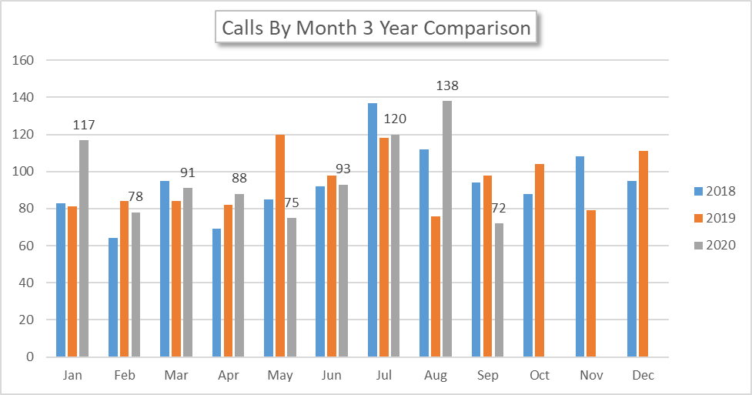
Breakdown by Major Incident Type

Detailed Breakdown by Incident Type

Detailed Breakdown by Incident Type
INCIDENT TYPE | # INCIDENTS | % of TOTAL
131 - Passenger vehicle fire | 1 | 1.39%
141 - Forest, woods or wildland fire | 1 | 1.39%
311 - Medical assist, assist EMS crew | 7 | 9.72%
321 - EMS call, excluding vehicle accident with injury | 25 | 34.72%
324 - Motor vehicle accident with no injuries. | 2 | 2.78%
444 - Power line down | 2 | 2.78%
552 - Police matter | 1 | 1.39%
553 - Public service | 1 | 1.39%
554 - Assist invalid | 2 | 2.78%
561 - Unauthorized burning | 1 | 1.39%
611 - Dispatched & cancelled en route | 15 | 20.83%
622 - No incident found on arrival at dispatch address | 9 | 12.5%
651 - Smoke scare, odor of smoke | 3 | 4.17%
733 - Smoke detector activation due to malfunction | 1 | 1.39%
911 - Citizen complaint | 1 | 1.39%
TOTAL INCIDENTS: | 72 | 100%

Call History

