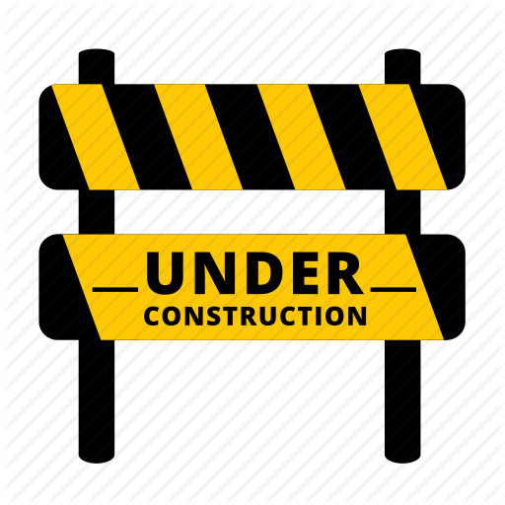
The City Hall and Library Parking Lot
Will be CLOSED for repair work
Sunday, 9/26
and Monday 9/27
Weather Permitting
We apologize for any inconvenience

