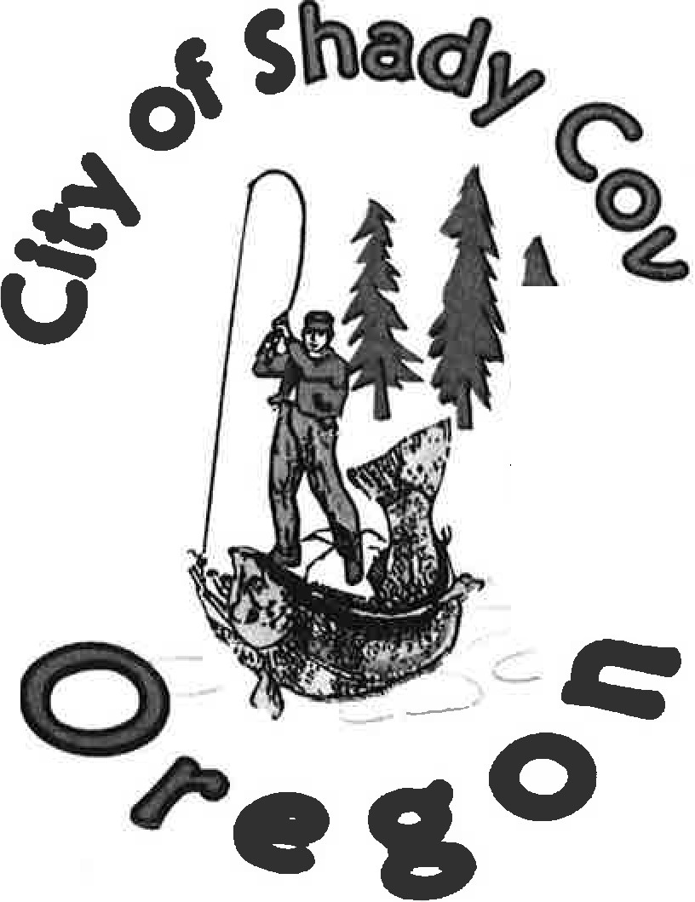
Inc.
l
1972

Strategic Plan

Adopted July 19, 2001

The City of Shady Cove's first Strategic Plan was adopted by the City Council in October of 1996.

Since that time, a great deal has been accomplished through the efforts of elected and appointed officials, staff, and citizens at large. Not all of the achievements were specified in the Strategic Plan, but all contributed to the welfare and progress of the City.
Major achievements since October 1996 include: Financial recovery and 4 years of fiscal stability
Growth reduced to a manageable level [Assisted through the implementation of
System Development Charges, an updated fee schedule and consistent application of land use laws]
Updated City Charter approved by the citizens Ordinances updated
Created the City Administrator position [That position was filled without an additional tax levy.]
Employment of a well-trained staff, approaching an appropriate size to serve the City's needs
Police levy approved by the citizens Established a budget to promote tourism
Significant progress on the update of the Comprehensive Plan Secured aerial topographical surveys for the entire City Wastewater system rehabilitation and upgrade, well underway Developed a master Transportation Plan
Developed a master Storm Drainage Plan Developed a master Water Plan
Implemented a plan to improve all City streets Capital improvements made in Aunt Caroline's Park
Accumulation of funds for Park and Recreation development Provided accommodation for Grades 7 and 8
Implementation of communication media [INSIDER, City Web Page, Catch the Spirit]

Collectively, we have made considerable progress. Yet, the list of needs before us is extensive. The last few pages of this document highlight some of those needs. A reliable water system, for the long-term health and safety of the citizens, is the most critical need. To meet that need, all citizens must work together for the overall benefit of the entire community.
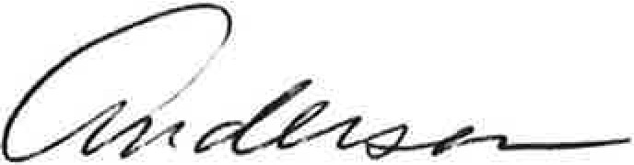

Table of Contents

Introduction 1

Shady Cove: Yesterday and Today 2

A Vision for the Future 5
Status of Previous Strategic Plan Goals 6

2001-The Vision Revisited 16
Updated listing of short and long-term goals as of June 2001 17

Recommendations 20

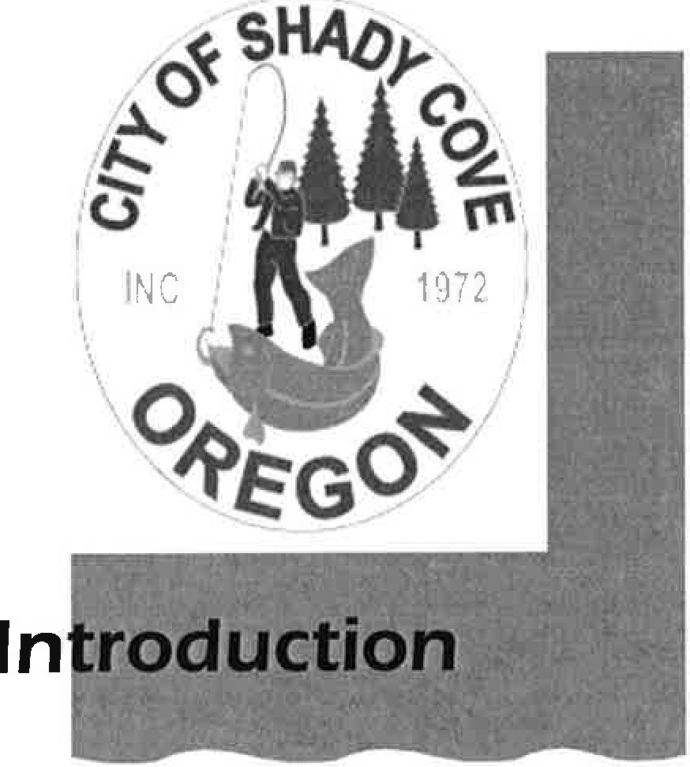

The City of Shady Cove's Strategic Plan is our community's statement of how it will achieve its vision for the future.

It is a practical plan, providing both short-term and long-term guidance to elected officials who serve the community's interests.

It is called the Strategic Plan because it embodies the joint development efforts by our elected and appointed officials, and our citizens, businesses, and regional governmental agencies.

It preserves what they most value about the community of Shady Cove, and strengthens the path along which we all journey together to ensure future change enhances and preserves those values.

Shady Cove residents enjoy a sense of place and a sense of community. We talk about our city, pointing to the beautiful Rogue River that runs through it, the natural beauty that surrounds us, and the small, close-knit family atmosphere that makes Shady Cove a wonderful place to live.

Our citizens and community leaders want to ensure those qualities remain as the town grows and matures in healthy and productive ways.

The Strategic Plan process was funded in late 1994 with a $25,000 grant from the U.S. Forest Service. $5,000 of this amount was earmarked for implementing parts of the Shady Cove Strategic Plan. The Rogue Valley Council of Governments (RVCOG) helped facilitate the overall process. This process included three phases: community assessment; plan development; and plan implementation.

Working with residents, RVCOG, elected and appointed officials, and staff, the Strategic Plan identified resident values and issues, defined goals and strategies, and identified the long-term challenge of implementing the Strategic Plan.

The Strategic Plan developed in 1994 has been a place marker for our community; a living document from which elected officials and community leaders have derived and updated goals over time. It continues to serve this purpose today.

From the homesteads of the 1870's through today, people have been drawn to our area as they travel to Crater Lake, a popular vacation spot, enjoy the Rogue River, with its reputation as a resort fishing destination, and share in the rural atmosphere.

Periodic floods punctuated the City's history, with the first recorded flood occurring in 1869, followed by others in 1890, 1927, and 1964. By participating in the National Flood Insurance Program and complying with Federal Emergency Management Agency development
y
guidelines, Shady Cove has managed to avoid damage to life and property.

With its incorporation as a City in 1972, Shady Cove was able to build a desperately needed sewer system. By working together to reach common goals, Shady Cove evolved as a City with medical facilities, a library, parks, retail stores, public safety services, a school (Shady Cove School, serving Kindergarten through the 8th Grade), lodging and leisure services, and a multitude of non-profit groups such as 4H, the Greater Shady Cove Boosters, the Masonic Lodge, the Upper Rogue Community Center as well as other religious, social, and civic organizations.

While Shady Cove has a history of rapid growth, and at one time was the fastest growing incorporated community in Jackson County, it now has a healthy, planned, and well-managed growth rate of about three percent per year.

The City has seen the benefits of managed growth in the quality of maintenance for rural roads, and the addition of paving, curb and gutter in some areas. Enhanced storm drainage and sewer treatment and collection capacity, combined with conscientious, well-trained staff also reflect benefits derived from managed growth. Serving the community's needs is our top priority.

Growth in Shady Cove has brought new people and a variety of lifestyles, values, and priorities. The traditional community of single-family homes has evolved to include more multi-family residences, recreational vehicle parks, and mobile and manufactured home parks.

Yesterday and Today [continued from Page Two]

Changes in our community's makeup have placed new demands upon our streets, sewer, storm drain, parks, and public safety services. This is why it is so important to have a common vision and plans for implementing our community's goals for the future. The strategic plan is our way of ensuring we journey down the path to Shady Cove's prosperity, together.

Population

As of January 2000, Shady Cove has a population of 2,307. The population is evenly split between male and female with almost a third of the population evenly distributed between the age groups of 45 to 54 years of age and 65 to 74 years of age.

Housing

Family households with one child under 18 account for 24 percent of the population with married families representing almost 60 percent of our population. Renter occupied housing accounts for approximately 30 percent of our total housing units of 1,107. The remaining 715 homes are owner-occupied. Vacant housing for seasonal, recreational, or occasional use is about two percent, and the vacancy rate for total housing units in the City is about 10 percent.

With the stable growth, and proximity to housing, health, and social and leisure activities, Shady Cove continues a trend toward becoming a retirement community. Growth in the local retirement community has invigorated the construction trades related to residential building, as well as other trades and services targeting this group.

The average home price between 1980 and 1990 was $75,000, with rentals averaging about $300 per month. Today, the average selling price for homes in Shady Cove is
$150,000, with rental units averaging $450 to $750 per month.

Economy

With its location only 23 miles from Medford, the county seat, and regional center, Shady Cove is within an attractive commute distance for many of our residents. The majority of workers from Shady Cove commute to the Medford and White City area.

Yesterday and Today [continued from Page Three]

Shady Cove's labor force increased by almost 32 percent between 1980 and 1990, with the bulk of these working in the retail trade. The number of retirees affects the average level of income and Shady Cove, while not an affluent community, is a community of diverse interests and very few people receiving public assistance.

Shady Cove's economic history remains intrinsically linked to tourism and recreation. Opportunities abound for rafting, fishing, hunting, photography, bird watching and more in the lee of the beautiful Cascades.

Over the weekend of November 4, 1995, about 75 citizens of our community met to establish a vision and Strategic Plan for Shady Cove. The vision included the following.

We want a community ....

With a diverse range of ages and incomes
A
That is environmentally sound and in harmony with nature
Where the river is a showcase with access for residents and visitors With managed growth
With professional, responsive and effective government That maintains the rural lifestyle
With citizens who are involved in the affairs of their community.

Issue areas and strategies to achieve the vision were embodied in the goals enumerated in the following pages. The status today of those goals that were set in 1995 and revisited in 1996, 1997, and 2001, is also included with the enumerated goals.

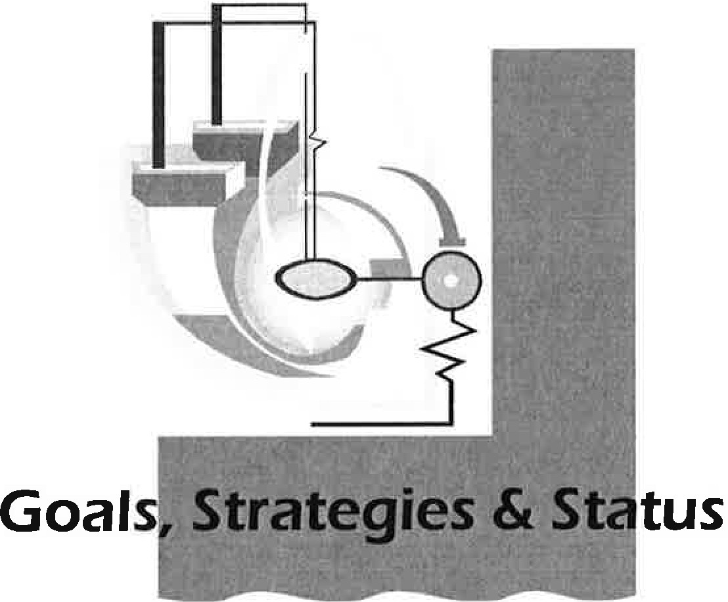

Goal:

Shady Cove Beautification

To make Shady Cove an environmentally attractive rural community, with the river as a showcase and access for residents and visitors alike.

Strategy A: Establish architectural standards for all future development in the commercial areas.

Status: Plans were developed and presented to the City Council in late 1996. The Citizens Advisory Committee plans to review and resubmit a plan to the Council with one Councilor to act as liaison for the subject.

Strategy B: Landscape the area in front of City Hall, the Upper Rogue Community Center, and the Library and possibly the Masonic Lodge.

Status: Landscaping of the area in front of City Hall, the Upper Rogue Community Center and Library has been completed. The development of a master plan is proposed, in concert with Strategy A above, which includes a requirement to plant trees when doing work for which a permit is required.

Goals, Strategies & Status

Beautification [continued from Page 6]

Strategy C: Plant trees along Highway 62.

Status: A grant to evaluate appropriate trees was awarded with Strategy A, above, but not acted upon because no arborist responded to the City's request for proposals.

Restructuring Government

Goal 1: To completely revise the City Charter.
Strategy A: Utilize the League of Oregon Cities' suggested changes and model as basic outline for City Charter revisions.

Status: The suggested changes and model were used.

Strategy B: List of recommended revisions

Status: The Charter was revised and updated, and approved by the voters in 1998. Not all recommendations were included.

Goal 2: To revise regulations regarding the City Planning Commission.

Strategy A: Revise Ordinance #2 to conform to current requirements.

Status: Ordinance updated and approved by the City Council in December 1998.

Strategy B: Establish annual "Planning Commission Rules of Government."

Status: Complete. The annual review by the City Council was established in 1997, but has not been implemented.

Goals, Strategies & Status

Restructuring Government [continued from Page 7]

Goal 3: To review and revise "Shady Cove City Council Rules of Government:" and provide easy to understand procedures for Council and Planning Commission meetings.

Strategy A: City Council will revise the "Shady Cove Rules of Government" annually.

Status: Rules of Government have been updated annually since January 1997.

Strategy B: City Council will include a requirement for Town Hall meetings in the Rules of Government.

Status: Not included.

Strategy C: The City will contract to provide training for City Council members on laws, regulations, and procedures for effective operation and handling of City Council meetings and matters.

Status: Training is provided through a combination of manuals provided to new members, Rogue Valley Public Service Academy and League of Oregon Cities training sessions.

Goal 4: To begin the process to obtain a City Manager.
Strategy: The City Council will develop proposals for City Manager funding.

Status: A City Administrator was first employed in February 1999. The position is funded through public works resource, increase in Pacific Power franchise fee and a portion of transient occupancy tax from the Edgewater Inn.

Goals, Strategies & Status [continued from Page 8]

0 n g m

Goal 1 : Complete the update of the Comprehensive Plan
Strategy A: Develop a community involvement process for the Comprehensive Plan review.

Status: A Citizens Advisory Committee was selected/appointed in early 1997. The committee has been in the updating process since that time.

Strategy B: Incorporate the Shady Cove Vision and community-defined character into current and long-range planning.

Status: To the extent that the Department of Land Conservation and Development (DLCD) rules allow, the Shady Cove Vision is included in the process.

Strategy C: Secure funding for professional services and consulting to assist in updating the Shady Cove Comprehensive Plan.

Status: Grants have been received from both the DLCD and the Oregon Department of Transportation (ODOT). The City contracts with RVCOG for the services of a planner to provide professional advice to City Planning Department staff. Some of the latter cost is born by the City.

Strategy D: Define the Comprehensive Plan review process, including what Shady Cove has done in the past and what State law requires.

Status: After almost four years, the update of the Comprehensive Plan is nearly complete. This should be accomplished by mid-year 2001, however some difficult issues remain to be resolved: Transportation Plan; Buildable Lands and Riparian setback.

Goals, Strategies & Status

Growth Management [continued from Page 9]

Goal 2: Develop understandable, consistent planning.
Strategy A: Define and flow chart the different planning processes with strengths and weaknesses.

Strategy B: Take corrective action in any area of weakness.

Strategy C: Identify all existing planning tools and how they fit in the flow chart.

Status: These strategies have not been employed. The application process has been revised, including action specific applications, and an evaluation of each process resulting in several applications being handled by staff in a more efficient manner. The process is working well.

Strategy D: Update fee schedule and cost-of-service study.

Status: Complete. Reviewed regularly by staff and City Council.

Goal 3: Develop a Master Plan for all infrastructure
Strategy A: Identify the need for master plans and Shady Cove's ability to fund them.

Status: Complete master plans for storm drainage and wastewater treatment are on file. A transportation plan has been approved by the Council, but not DLCD. A feasibility plan for water has been developed, but the public has not approved funding.

Strategy B: Identify growth areas and the volume of population growth.

Status: Included in the Comprehensive Plan update.

Strategy C: Identify the cost of growth, including the overhead administrative and service costs, such as Administration and Police. Identify the revenue to cover those costs.

Goals, Strategies & Status

Growth Management (continued from Page 10)

Status: Cost of service is identified. The 10 percent average annual growth between 1990 and 1996 resulted in near bankruptcy. Growth has been managed since then at about 3 to 3.5 percent per year. While the market place does dictate, revised planning fees, implementation of System Development Charges, and consistent application of the Zoning and Subdivision Ordinances has played a significant role.

Without a public water system, any growth could deplete existing water stores and thus "dry up" the City, wiping out everyone's investment.

Strategy D: Identify areas of management and maintenance.

Status: This was not pursued because the strategy was vague.

Education/Recreation

Goal 1 : Create more recreational and education opportunities for all ages.
Strategy A: Develop a partnership between the Shady Cove School and the City that allows maximum use of our community facilities and equipment by all residents.

Status: Not implemented.

Strategy B: Explore the idea of opening a computer lab at the school.

Status: A computer lab at the Upper Rogue Community Center was not successful and private sector local computer labs were also abandoned.

Goals, Strategies & Status

Education/Recreation [continued from Page 11]

Strategy C: Develop summer activities for youth.

Status: Not implemented. Multiple offers have been made to provide seed money for recreational facilities for youth, however, numerous attempts to solicit participation in a City Recreation Commission to develop and recommend funding sources, have been unsuccessful.

Goal 2: Provide local K-12 schools.

Status: Grades 7 and 8 have been relocated from Eagle Point to Shady Cove. Construction of permanent classrooms is included in the bond measure that passed in November 2000, for improvements to schools within the Eagle Point District 9. (Relocation of grades 9 through 12 from either Prospect or Eagle Point to Shady Cove is unrealistic in the near future.)

Goals, Strategies & Status [continued from Page 12)

Water

Background

The City of Shady Cove does not have a municipal water system and this was identified as a critical issue during the 1990's and in the 1995 Strategic Plan process. Some wells within and around the City had gone dry and there were reported problems with contamination. The Health Department was aware of problems with minerals, contamination by petroleum products and bacteria, as well as inadequate well yields. The lack of a water system also created safety concerns and constrained development. In 1994, Shady Cove was declared a "Fire Hazard Area," which restricts certain types of building and adversely affects the local economy.

A 1990 privately sponsored feasibility study led to a vote on a bond issue for a water system. Voters did not approve the bond, with much of the opposition based on the incorporation of property values into the rate formula. In 1999, the City sponsored a ballot measure for a water system, and that was also unsuccessful. Today, support for a water system is widespread, but not unanimous.

Goal: To provide an affordable public water system for Shady Cove.

Strategy A: Determine if the citizens want a public water system and what they are willing to pay.

Status: Generally speaking, the majority of citizens are in favor of a public water system, but are not yet prepared to pay for it.

Strategy B: Develop funding.

Status: Again, it was determined that grant and long-term, low­ interest loans were available to Shady Cove. The cost has risen dramatically from 1992, and grant money has diminished from 57 percent to about 35 percent of the total project cost.

Goals, Strategies & Status [continued from Page 13]

Strategy C: Gather the facts needed to convey to the public. Strategy D. Develop printed literature to share with the public. Strategy E: Build a team to sell the concept.
Status: All the action plans outlined for these strategies were implemented for the 1999 effort, which was unsuccessful. The Organizing Committee to Create the Shady Cove Water District, a group of private citizens, is working to gather data to support the formation of a privately owned water district.

Goals, Strategies & Status [continued from Page 14]

River

Goal 1: To ensure free river access for Shady Cove residents.
Strategy A: Identify sites that meet the following criteria: riverside location; nearby access to water service; space to develop for parking; large enough for a variety of uses.

Status: Some sites have been identified, including the ODOT property at the southeast corner of the City. The City continues to pursue the ODOT property for public use. Interest has waned due to a shortage of financial resources.

Strategy B: Once a site has been identified, forward the information to the City Council for consideration and action

Status: ODOT property is the only parcel brought forward to the Council.

Goal 2: Educate the public about preserving the river, its banks, and fish.
Strategy: Design and distribute place mats for restaurants that help people learn about the river.

Status: Place mats were developed and distributed for over one year.

Goal 3: Clean up the river and its banks
Strategy: Litterbags were distributed for one year following the suggestion.

Status: The Greater Shady Cove Boosters have adopted a large section of the river and clean it at least once a year, with the assistance of the Rogue River Guides Association.

In January of 2001, the City began the process of revisiting the Goals and Strategies identified in 1995.
2001

The Council, staff, Rogue Valley Council of Governments, and the public identified the status of goals and enumerated the goals that were still viable and goals that needed to be updated or added to the Strategic Plan.

Over the course of several months, a new, improved, and revised Strategic Plan was developed with
a focus on short-term and long-term goals. The objective was to focus the Strategic Plan on those issues that the City Council and the City could influence or control.

The listing on the following pages identifies the short-term goals, those that are achievable from January 2001 through December 2002, and the long-term goals, which will extend beyond December 2002.

City of Shady Cove
Short-Term Goals
January 2001 through December 2002

City Hall Improvements
(contract for a detailed construction design)

Comprehensive Plan

♦
♦
- Expand City Hall
- Provide an adequate Police
♦
facility
♦
- Install American with
Disabilities Act compatible
Complete the periodic review
Establish a commercial overlay for downtown
Include pedestrian/bicycle paths Include an alternate to Highway 62 in the core commercial area

bathrooms
- Provide a new water source (well)
- Pave parking lot
- Reconfigure landscaping

Infrastructure

- Rehabilitate Lift Station Numbers 3 and 4

♦

Parks & Recreation/Tourism
& Promotion/ ♦

Beautification
Improve the Rene Drive and Rogue River Drive intersection Provide support for a public water system

- Install decorative lights on the bridge
- Develop an Architectural Standards Ordinance
- Develop a Sign Ordinance for uniformity
- Install a public bathroom in Aunt Caroline's Park
- Acquire additional park land

Adopted 05-03-01

City of Shady Cove

Short-Term Goals
January 2001 through December 2002

- Establish a 5 to 10 year plan for Public Works.

- Establish a volunteer position to follow up on conditions of building approval.

- Continue to encourage public involvement in City affairs.

4rfnn+atl nli.n'1.n1

City of Shady Cove

Long-Term Goals

  - Ensure continued financial stability.
  - Develop additional park and recreation facilities.
  - Rehabilitate and expand the wastewater treatment plant.
  - Construct a storm drainage system.
  - Improve all City streets.
  - Assist with the development of a public water system.

Adopted 05-03-01

This revision of the City of Shady Cove Strategic Plan has been guided by input from community members, the Shady Cove City Council, the Citizens Advisory Committee, the Shady Cove Planning Commission, staff, and the Rogue Valley Council of Governments. This input is the basis for the vision for the new millennium. It is meant to provide both short-term and long-term goals and to be the basis of developing workable, implementation strategies. The City Council and the community gives thanks to all the participants for their commitment and countless hours of review, evaluation, and insight which led to the development of this updated Plan.

As in the past, it is recommended that the City Council revisit this Plan and specifically the short-term and long-term goals, on an annual basis to ensure the continuing relevance of stated goals, and determine if new goals should be added.

Regular review of this plan will also provide an opportunity for the entire community to celebrate the successful completion of goals and to maintain perspective by balancing past activities in the context of the future vision contained in this dynamic document.

City of Shady Cove, Oregon

22451 Highway 62 Post Office Box 1210
Shady Cove, Oregon 97539

Phone: Facsimile:
[541] 878-2225
[541] 878-2226

E-mail: shadycovecityhall@grrtech.com Web Site: www.shadycove.com

Shady Cove City Council

Mayor President Councilor Councilor Councilor
Tom Anderson Lois Holland Alison Curtis Jack Henson Fred Wendt

Departments

City Administrator | 878-3757
City Recorder | 878-3200
Billing Services | 878-2225
Planning Department | 878-2225
Police Department | 878-3200
Public Works Director | 878-3322

This 2001 Shady Cove Strategic Plan is available electronically on the Shady Cove web site. Copies are on file at City Hall and available at the Shady Cove Library, Upper Rogue Community Center, Chamber of Commerce and local businesses.

Compiled and adopted by the City of Shady Cove City Council, July 19, 2001.
111..llJll._

